Title
Complexity Analysis of a Hospital Patient Record System Using Nested Loops

Aim
To analyze the time complexity and space complexity of detecting duplicate patient records using nested loops.

Problem Statement
A hospital maintains patient records in a database. To detect duplicate entries, every patient record is compared with every other patient record using nested loops.
Analyze the algorithm by:
- Recalling what nested loops imply in complexity analysis.
- Explaining why execution time increases.
- Determining the time complexity.
- Determining the space complexity using asymptotic notation.

Algorithm
- Store patient records in a list.
- Use an outer loop to select each patient record.
- Use an inner loop to compare it with every remaining record.
- If two records are equal, report a duplicate.
- Continue until all comparisons are completed.

Source Code
n = int(input("Enter the number of patient records: "))
patients = []
print("\nEnter Patient IDs:")
for i in range(n):
patient = input(f"Patient {i + 1}: ")
patients.append(patient)
print("\nHospital Patient Record System")
print("--------------------------------")
print("Patient Records:")
print(patients)
print("\nDuplicate Records:")
found = False
for i in range(n):
for j in range(i + 1, n):
if patients[i] == patients[j]:
print("Duplicate Record Found:", patients[i])
found = True
if not found:
print("No duplicate records found.")
print("\nComplexity Analysis")
print("--------------------")
print("Time Complexity : O(n²)")
print("Space Complexity: O(1)")

Output
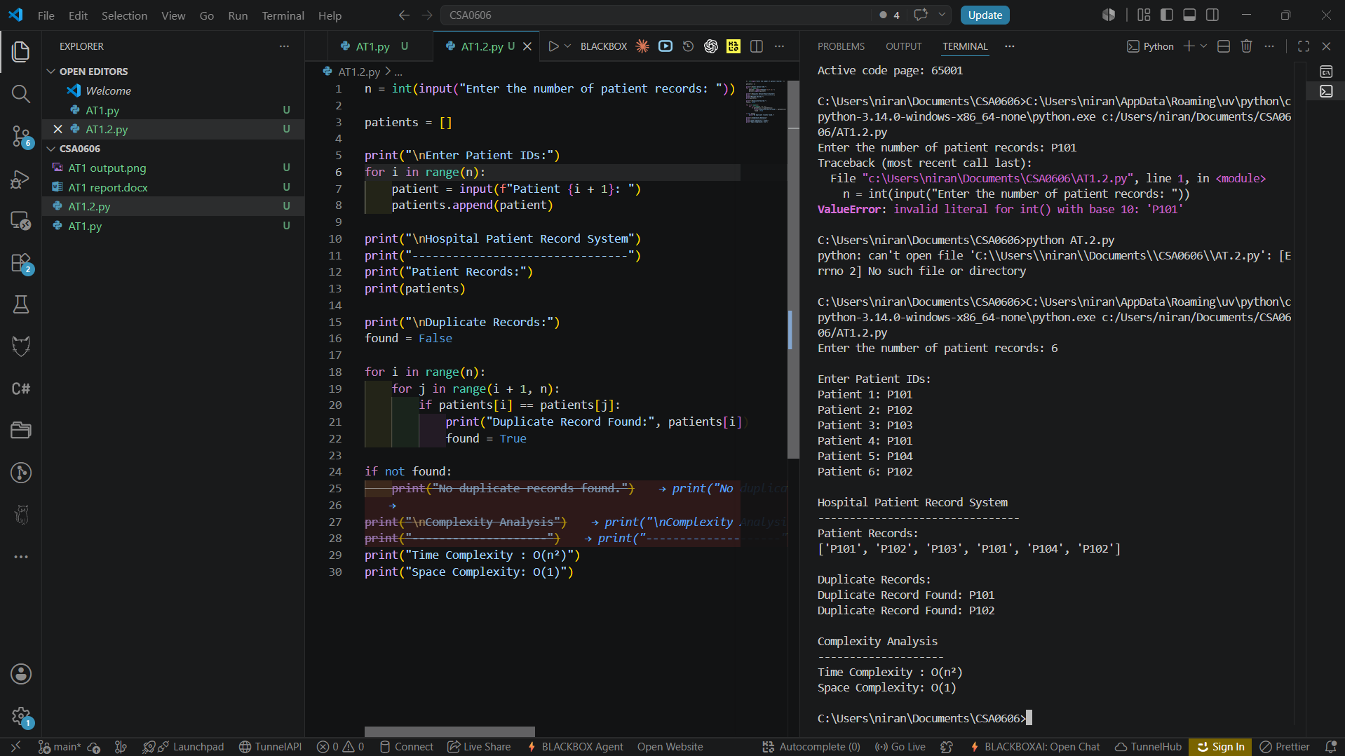

Complexity Analysis

What do Nested Loops imply?
Nested loops mean that one loop executes completely for every iteration of another loop.
If there are n patient records,
- The outer loop runs n times.
- The inner loop also runs approximately n times.
Therefore, the total number of comparisons becomes
n×n=n2n \times n = n^2n×n=n2
Hence, the algorithm has quadratic growth.

Why does execution time increase?
Each patient record is compared with every other patient record.
For example,
Number of Records | Comparisons (Approx.)
10 | 100
100 | 10,000
1,000 | 1,000,000
10,000 | 100,000,000
As the number of patient records increases, the number of comparisons increases rapidly, resulting in longer execution time.

Time Complexity
The outer loop executes n times.
The inner loop also executes approximately n times.
Therefore,
T(n)=n×n=n2T(n)=n\times n=n^2T(n)=n×n=n2
Hence,
O(n2)\boxed{O(n^2)}O(n2)​

Space Complexity
The algorithm uses:
- loop variable i
- loop variable j
- Boolean variable found
These require constant memory regardless of the number of patient records.
Therefore,
O(1)\boxed{O(1)}O(1)​

Asymptotic Notation
Complexity | Value
Best Case | Ω(n²)
Average Case | Θ(n²)
Worst Case | O(n²)
Space Complexity | O(1)

Analysis
- Nested loops compare every patient record with every other patient record.
- The number of comparisons grows quadratically as the number of records increases.
- The algorithm requires constant extra memory because no additional data structures proportional to n are used.
- Although simple to implement, this approach becomes inefficient for large hospital databases due to its O(n²) execution time.

Conclusion
The hospital patient record system uses nested loops to compare every patient record with every other record for duplicate detection. Since both loops iterate over the records, the total number of comparisons grows proportionally to n2n^2n2, giving a time complexity of O(n2)O(n^2)O(n2). The algorithm uses only a few extra variables, resulting in a space complexity of O(1)O(1)O(1). This approach is suitable for small datasets but becomes inefficient as the number of patient records increases.

